Oral presentation

The development and implementation of two national beach safety signage standards (UK & Australia) and how they are leading to the creation of an
international beach signage standard.

Steve Wills RNLI, Poole, UK
Steve Wills† RNLI, Poole, UK

Every year there are thousands of coastal drownings and accidents around the world. Many of these deaths are linked directly to poor information or a lack of understanding of the potential dangers. The terrible truth is that every year children and adults die unnecessarily around the world’s beaches. It is all too common to hear bereaved parents say that they were unaware of the dangers and had not seen any warning signs, and more often than not signage is questioned by the coroner after a drowning and subsequently highlighted as a means to reduce risk in future.

In recent years, both the UK and Australia have developed beach safety signage systems and guidelines to help combat drownings. This work has been undertaken in the UK by the RNLI [Royal National Lifeboat Institution] and by Surf Life Saving in Australia led by LSV [Life Saving Victoria] in Australia. These new industry standards and guidelines can now be widely seen in both countries, and are having a positive effect as part of their national drowning prevention strategies.

Representing their organisations and national standards bodies, the RNLI and LSV, alongside other international representatives are working closely with ISO [International Organisation for Standardization] to help produce guidance information and standards for a global beach safety signage system. By having internationally recognised signs on beaches throughout the world there is a great potential to significantly reduce coastal drownings and accidents.

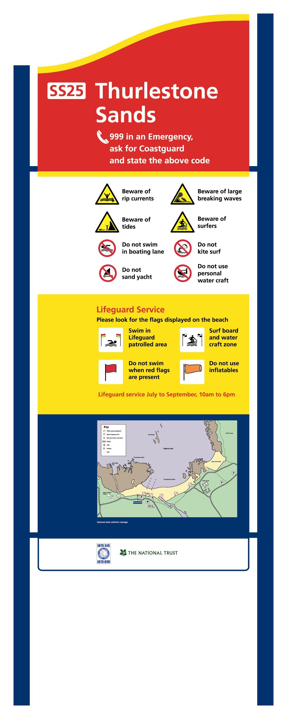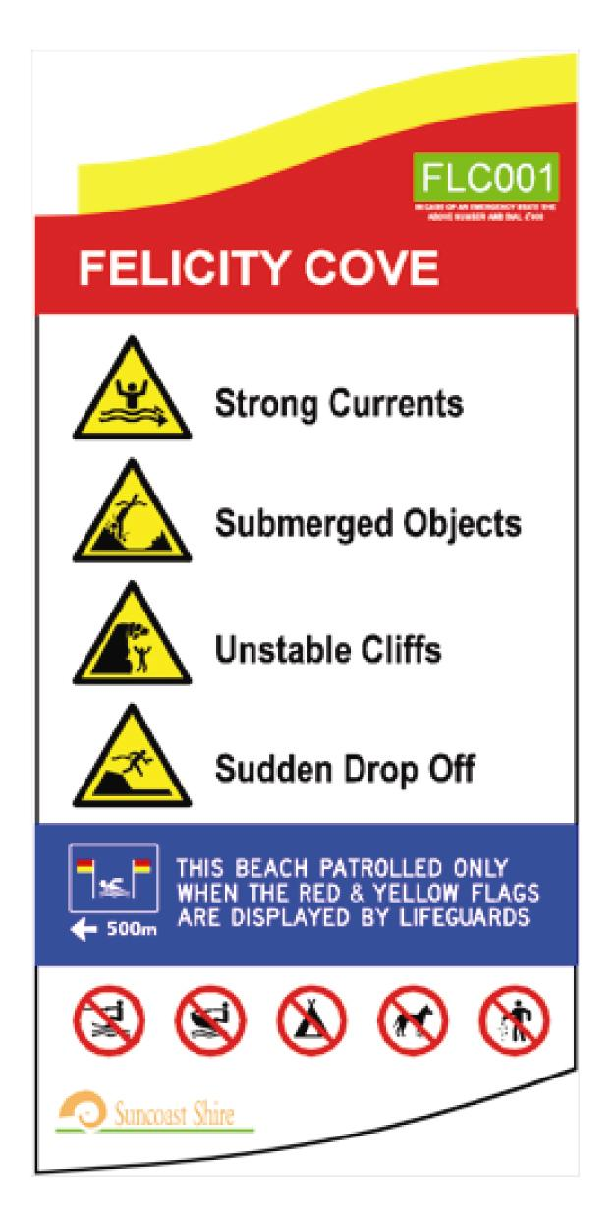

Left to right: UK [RNLI] primary sign, Australian [LSV] primary sign

†Corresponding author:
Steve Wills
RNLI, Poole, UK, BH15 1HZ E-mail swills@rnli.org.uk Tel +44 1202663465 Fax +44 1202 663550
E-mails of co-authors: Brett Ellis: brett.ellis@lifesavingvictoria.com.au

Learning outcomes:
1. To learn how effective beach safety signs can reduce coastal drownings and accidents.
2. To understand the process and research stages that the UK and Australia have undertaken.
3. To learn more about the what’s happening internationally to develop a global beach safety signage standard.

