ORAL
Abstract

Rock Fishing Safety

Malcolm Poole – President - Recreational Fishing Alliance of NSW (RFANSW)
Stan Konstantaras† – President - Australian National Sportsfishing Association
New South Wales Branch (ANSANSW)
Sydney – Australia

Recreational fishing in New South Wales (NSW) is a very popular activity, enjoyed by many throughout its fish rich waters during any year. Rock Fishing is one particular fishing activity which is recognised as a high risk that can be fought with danger or death, if some basic steps are not followed by those participating.

The New South Wales Water Safety Taskforce, consisted of a small group of members from key government departments initiated an investigation into the increasing reports of Fatalities associated with the activity of Rock Fishing in 2000.

The report ‘Investigation into the Coronial files of Rock Fishing Fatalities that have occurred in NSW between 1992 and 2000’ was completed by Matthew Jones in September 2003. It identified that there had been 74 recorded deaths relating to Rock Fishing between 1992 and 2000 in NSW. Through several key areas of data collection it concluded that more effort was required to curb this upward spiral.

In late 2003 a Coronial inquest into the deaths of two prominent and well known Sydney recreational fishers highlighted the task force report, along with several other very restrictive recommendations. This provided the catalyst to develop an Education and Awareness Campaign for recreational fishers in NSW.

The NSW Recreational Fishing Saltwater Trust Expenditure Committee supported funding of $88k in 2004. The project proponents were the NSW Department of Sport and Recreation and the Recreational Fishing Alliance of NSW who jointly managed it, with the support of recreational fisher from ANSANSW, the Tackle Industry providing the services of well known Australian Fishing presenter Andrew Ettingshausen aka ET, the Fishing Media providing print media support along with assistance from NSW Fisheries.

The Rock Fishing Safety project was completed in April 2007, it has seen the development and production of a free Rock Fishing Safety DVD, the successful running of several Rock Fishing Workshops with an emphasis on Chinese and Korean participants, the deployment of a Community based Information Package, and a Community Service Announcement (TV Add) for broadcast by Television stations.

All these packages deliver the basic messages in English as well as several other languages, about how to safely enjoy Rocking Fishing, reinforcing the education and awareness campaign message - ‘Don’t Put Your Life on the Line’.

The success of the Rock Fishing Safety theme is now being expanded to spread the Fishing Safely message covering all forms of fishing in NSW.

Learning outcomes
- Provide an Education and Awareness Campaign to reduce the number of Rock Fishing Fatalities in NSW
- Equip Recreational Fishers with Rock Fishing Safety information in English and several other languages
- Provide valuable hands on opportunities and information to NESB communities on how to correctly prepare yourself for a rock fishing trip

Presenting author:  Name: Malcolm Poole  Address: 9 Walmsley Road Ourimbah  New South Wales Australia 2258  E-mail: president@rfanswcom.au  Tel: 0612 4362 1687  Fax: 0612 4362 1387  Web Site: www.rfansw.com.au | Corresponding author:  Name: Stan Konstantaras  Address: The  New South Wales Australia 2036  E-mail: secretary@rfansw.com.au  Tel:0612 9344 0331  Fax: 0612 9344 4695

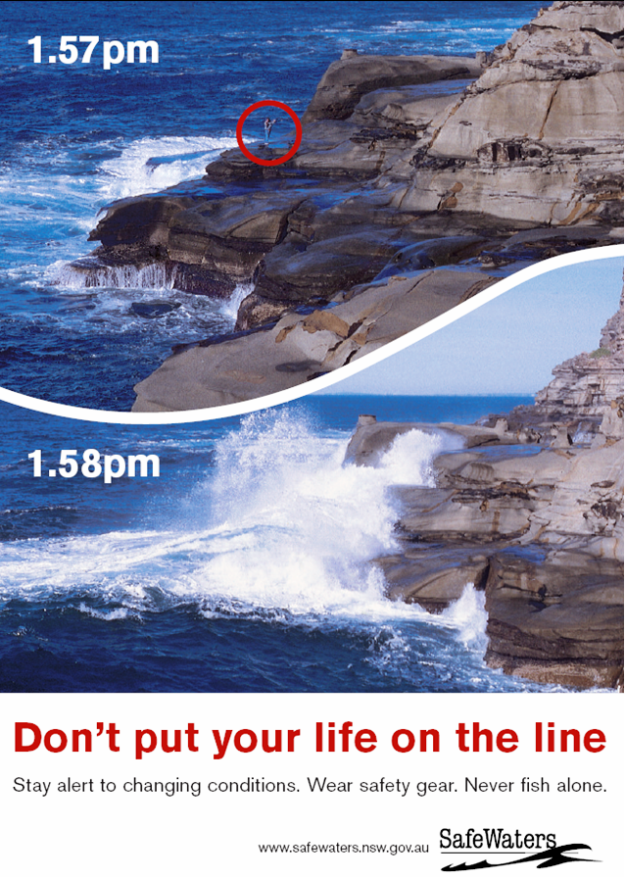  2003 SafeWaters Poster Campaign | 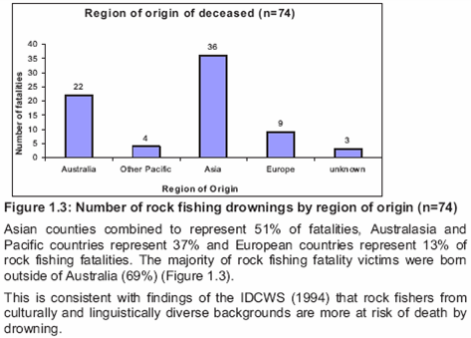  Extract from Report - showing origin of deceased fishers studied.
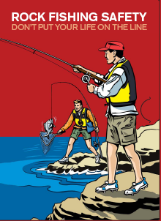
The Community Folder – containing the Rock Fishing Safety DVD,
interactive CD-Rom and information leaflets on Rock Fishing Safetyand

