ORAL
Abstract

What Can Science Teach us about Lifesaving and Drowning Prevention

†Principal Author:
Francesco A. Pia, Ph.D., member
American National Red Cross
Advisory Council for First-Aid, Aquatics, Safety and Preparedness (ACFASP)

Context
Human information processing, an evidence based scientific model, permits lifesavers to understand, disallow, or formulate research questions about vigilance and scanning practices.
Project.
A 1959 -- 1979 observational study was conducted to teach lifeguards to use automatic visual processing to detect the signs of an active drowning person. The study led to the drowning versus distress water crises categorical classification documented in On Drowning.
Discussion.
Typically lifeguards use a four part eye -- brain decision making model that employs the same visual and mental pathways, for all settings, to detect drowning and distress behaviors. Since varying degrees of research underlie the major patron surveillance practices, the need exists to delineate the capacities and limitations of short-term sensory storage, working memory, long-term memory, and the efficacies of saccade based sweep scanning, pattern scanning, and multistage scanning, and then correlate this data with the water crises categorical classification.
Implications.
The human information processing paradigm can channel the formulation of vigilance research questions and scanning research hypotheses. The efficacy of overburdening lifeguards working memory by requiring them to remember the characteristics of persons neither drowning nor in distress, after a scan has been completed, makes patron surveillance more difficult than necessary.

Learning Outcomes
1) Describe how visual data is viewed and processed in the brain during lifeguard surveillance of bathers.
2) Incorporate evidenced based bather scanning strategies into in-service training programs.
3) Understand the six patron surveillance variables and the 3 major scanning strategies within the human information-processing paradigm

†Corresponding author :
Francesco A. Pia, Ph.D.
3 Boulder on Brae Lane
Larchmont, NY 10538-1105
USA
frankpia@optonline.net: (914) 834-7536 (Tel & Fax)

Illustrations:
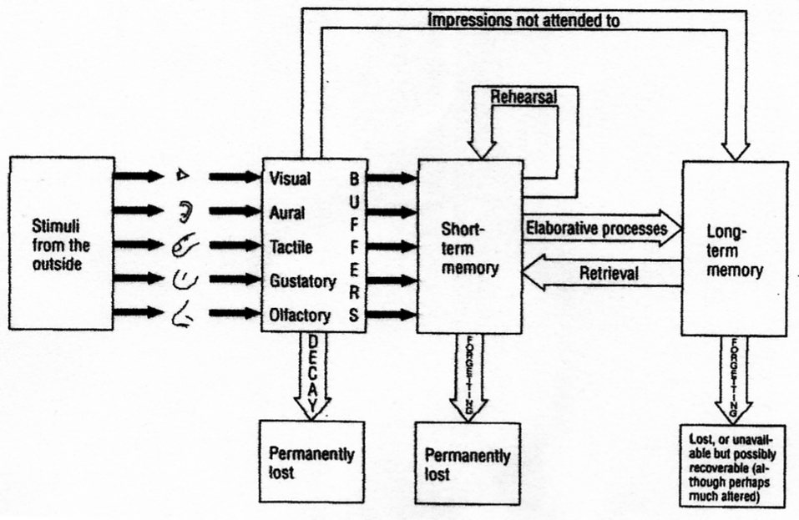

References
Creelman,D.C. & Macmillan, N.A., (2005) Detection theory, (2nd ed.), (Mahwah: Lawrence Erlbaum Associates)
Mackworth, N. (1948), The breakdown of vigilance during prolonged visual search. Quarterly journal of experimental psycholog,y 1, 5-61

Miller,G.A. (1956). The magical number seven plus or minus two: some limits on the hour capacity for processing information. Psychological Review, 63, 81-97
Pia, F. (1970) On drowning, [Motion picture], (Available from Water Safety Films Inc.)

Pia, F., (1999), Reflections on lifeguard surveillance programs. (In J. Fletemeyer, & S. Fres, (Eds.), New Science of Drowning: Prevention and Intervention, Boca Raton, CRC Press:, pages 231-243)

Pia, F. , (2006), Guarding against misconceptions, Aquatics International, May , 37-42

