ORAL
Abstract

COMPARATIVE ANALYSIS OF EDUCATIONAL PROGRAMMES

(Proposal for Innovation of Water Safety Educational Programme of Czech Red Cross in Relation to the Standards of the International Lifesaving Federation)

Jana Novotna, Tomas Miler†

Water Rescue Service of Czech Red Cross
Local Group Prague 1, v.s. 287
Ke skole1598
140 00 Prague 4
Czech Republic

†Corresponding author :
PaedDr. Tomas Miler, the Tutor of my Diploma Thesis (Dissertation)
FTVS, Katedra plavani, Jose Martiho 31, 162 52 Prague 6 - Veleslavin, Czech Republic
email: miler@ftvs.cuni.cz
tel. +420602187167

The educational programme of Czech Red Cross with current certification was commenced in the year 1990 and was revised in the year 1999. The aim of the research is to suggest an innovation of the existing educational programme in a way that it would correspond to contemporary worldwide trends in this specific area, i.e. to the ILS standards. The selection of countries for the comparative analysis with the Czech educational system and the ILS Standards was based not only on material/data availability, but, above all on the long term experience in education in/of the particular country. Slovakia was included to provide a parallel comparison of the progress after the Water Rescue Service of Slovak Red Cross was separated from the Water Rescue Service of Czechoslovakian Red Cross, also included were Ireland, Canada, UK and the USA. The certificates of each educational programme were divided into the following four groups: Junior Certificates, Basic Certificates, Training Certificates and Special/other Certificates. Partial criteria for comparison within the scope of each group were the age limits for entering a course, duration of the course and validation period of the certificate. Thanks to the detailed comparison, we succeeded in complementing the requisites of the final assessment criteria of our educational programme so that it corresponds to the outcomes and recommended ILS standards.

3 Objectives:
- getting/sharing the information (language barrier)
- Comparison – emphasizing the advantages of each (selected) programme
- Proposal for Innovation of Water Safety Educational Programme of Czech Red Cross

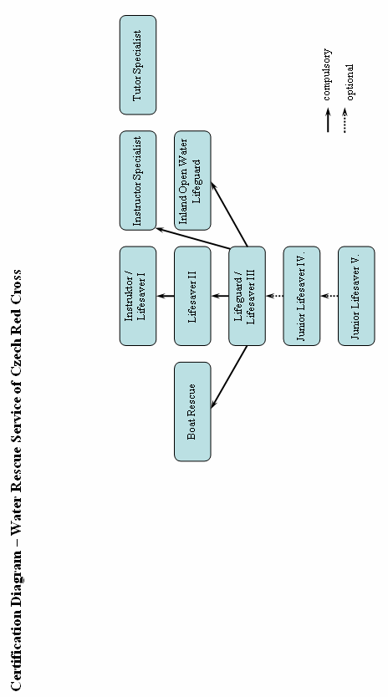

J U N I O R CERTIFICATION

Data marked (x) were not specified.
Yellow – certificates that can be a benefit for Czech Educational Programme.
Red – First Aid certificates that are separate, not included in Lifeguard Certificates.

