ORAL
Presentation
Abstract

“Kia Maanu, Kia Ora – Stay Afloat, Stay Alive”

A Water Safety Strategy for Māori in Aotearoa

Mark Haimona, Hamilton, New Zealand†

Aotearoa (New Zealand) has some of the most extensive and beautiful waterways in the world. The seas, rivers, beaches, and lakes provide endless opportunities to enjoy water activities such as gathering kai, swimming, hoe waka, diving, and fishing to name a few. For Māori, water is one of the greatest taonga (treasures) of this land - both physically and spiritually. However, while the number of people drowning in Aotearoa is decreasing overall, the number of Māori drowning is increasing.

Consider the following facts:
- Māori make up 12% of the total population, but represent 25% of total drownings
- 84% of Māori who drown are male aged between 25 and 64 years
- Gathering sea food is one of the biggest causes of drowning amongst Māori
- Māori children represent 44% of all the under five drownings

Whilst it might seem Māori are not giving water the respect it deserves, it is imperative to have Māori input into water safety content and design. ‘Kia Maanu, Kia Ora – Stay Afloat, Stay Alive’ is a water safety strategy that aims to integrate Māori cultural values through education to reduce the risk of water related injuries and drowning. The strategy recognises the importance of developing initiatives in the community through partnerships with water safety sector organisations, iwi, local government, schools and community groups. Since the strategy began Maori drowning has reduced from 28 in 2003 to 19 in 2006 – a reduction of 30%. This presentation will identify how Māori perspectives can assist in the development of a water safety strategy that embraces Māori values and can be integrated throughout the wider community.

Learning Outcomes

- An increase in water safety awareness for Māori including the promotion of key messages at national, regional and community levels.
- Enhancing water safety knowledge and skills through education and resources that reinforce cultural relationships and safer practice in and around water.
- Developing partnerships with key organisations, iwi and community groups that support water safety education and drowning prevention.

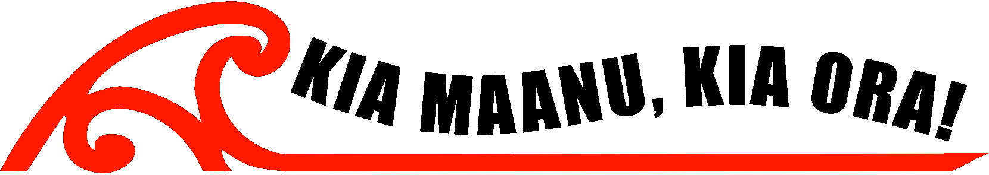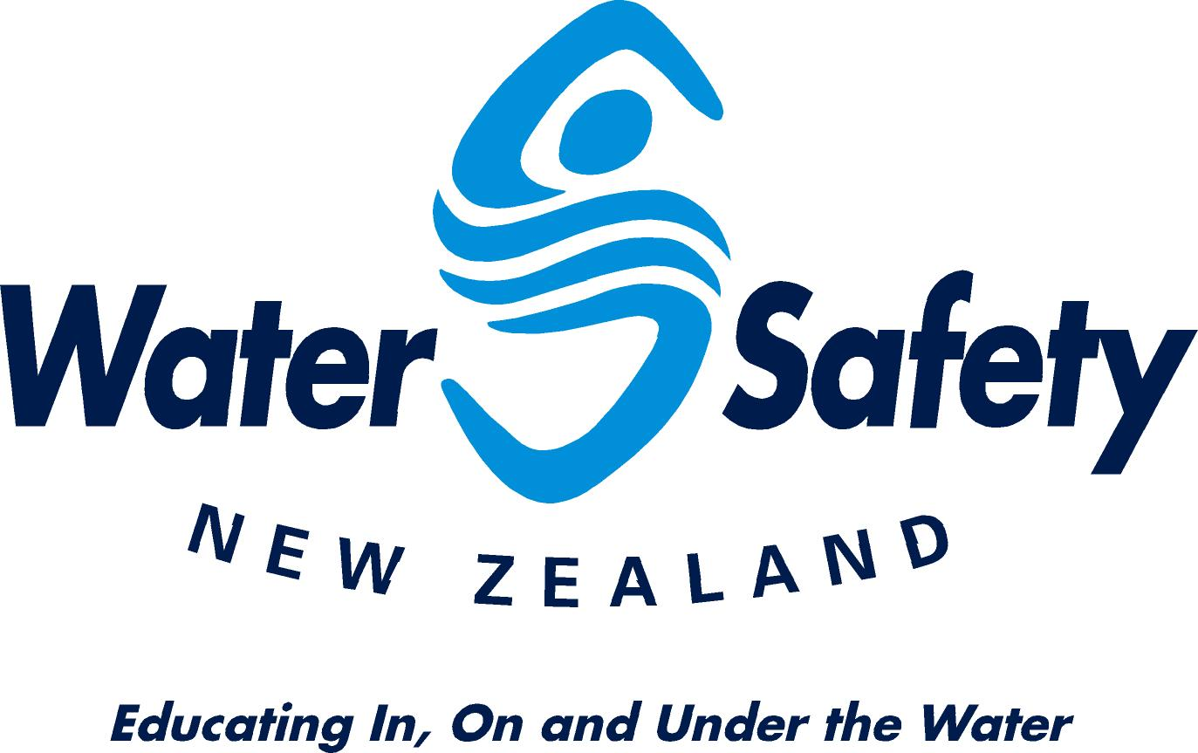

†Corresponding author :
Mark Haimona
PO BOX 10126
Wellington
New Zealand
mark@watersafety.org.nz
+ 64 276 840408 ph
+ 64 4 801 9599 fax

