ORAL
Abstract

Moderate sea states do not influence the application of an AED in rigid inflatable rescue boats

Wiebe de Vries MSc RN¹ † , Joost Bierens MD PhD MCDM²
¹ Educational Researcher, Doczero, Uden, The Netherlands.
² Professor in Emergency Medicine, VU University Medical Centre, Amsterdam, The Netherlands.

Context: The aim of this study was to determine if the AED can be operated correctly on board of rigid inflatable rescue boats (RIBs), and if downloading of data for quality control was possible.
Methods: Six AEDs were tested for their reliability, robustness and stability. Data were collected on three different types of RIBs (Table 1), in a harbour and at sea (Figure 1). Each AED was connected to a volunteer and a manikin simulating VF. Data from the AED were continuously collected.
Results: At the rescue boat type Atlantic, each AED became wet; no AED had a technical problem. When connected to the volunteer, the ECGs delivered by all AEDs showed a regular sinus rhythm. When connected to a manikin in VF, all AEDs were able to recognise VF and to provide a shock. There were differences in the time between first analysis and the shock. The voice prompt of one AED Plus was ‘understandable’, while the other AEDs were ‘difficult to understand’.
Downloading of data was not possible for three AEDs. We had a problem with the infrared connection, which means that evaluation and quality control afterwards may be difficult.
Discussion/Implications: The use of AEDs on RIBs during patient transport over calm water is possible and effective. The AED should have a screen for visual instruction, because the difficulty to understand spoken instruction during action at sea, and better features to download data.

Learning Outcomes
- All tested AEDs can be used on RIBs during their duty in nautical environment.
- All AEDs can recognize normal rhythm and rhythm disorder in aquatic environment.
- Organizations that consider the use of AEDs have to be aware that medical quality assurance may not be possible due the lack of the possibility for some AEDs to download data easy.

†Corresponding author:
Wiebe de Vries
Warande 69-A
2404 HS Alphen aan den Rijn
The Netherlands
E-mail: vries@doczero.nl
GSM: +31 646 591 201
Fax: +31 172 479 099

E-mails of co-author: jbierens@vumc.nl

Illustrations (Figures, Tables or Schemes):
Table 1; Technical aspects of the three types of RIBs used during the AED test
Figure 1; All AEDs became wet on the RIB type Atlantic

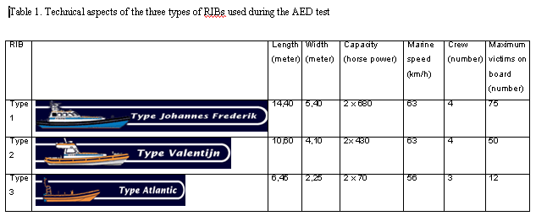

Figure 1
