Oral Abstract

RIP CURRENTS – A PUBLIC AWARENESS NEGLIGENCE

Mr. Erik Bech
General Manager, Surf Life Saving Denmark, Farum, Denmark

Abstract – The presentation covers topics spanning from rip currents fundamentals, to numerical modelling of rip currents, mapping and classification and general information flow to the public in a number of cases.
The learning objectives to the audience are to understand the following issues:
1. Public awareness and general information about rip currents (information)
2. Challenges in secure identification of rip currents by laypersons and specialists (observation)
3. Safe behaviour in the aquatic environment at the coastal beaches by the public (prevention)

Rip currents are considered to be a major safety problem at beaches worldwide, accounting for the majority of drowning accidents at coastal beaches.
To act safely if caught in a rip current is somewhat comparable to act safely in the traffic, e.g. when crossing a road. Crossing a road is a highly dangerous business, passing only inches from fast moving vehicles, which would either seriously wound or kill individuals or animals, not possessing a sufficient level of knowledge of the mechanisms behind the traffic patterns.
However, if you do posses the necessary knowledge and know the basic mechanisms and rules of the game in everyday traffic, you are able to be exposed to fast moving traffic and its dangers for hours every day, and still be fairly safe.
The analogy to rip currents is that if already known information about rip currents was circulated to the general public to a higher degree than it is today, many drowning and near-drowning accidents could be avoided.
Public awareness of rip currents is thus critical to reduce drowning deaths on a global scale, as well as continuous mapping and classification of rip currents on coastal beaches.

Author:
Erik Bech
Surf Life Saving Denmark, Ryttergaardsvej 118, 2. floor, 3520 Farum, Denmark
eb@svoem.dk, Tel +45 4439 4461 , Fax +45 4439 4460

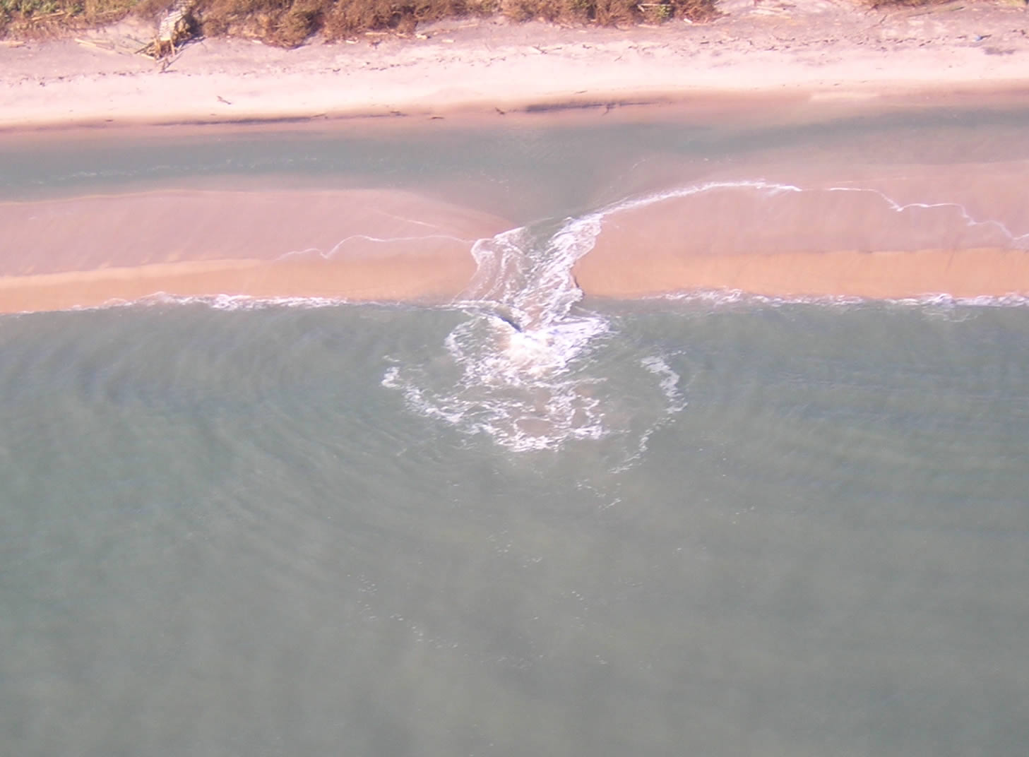
Courtesy of NOAA

Illustrations (Figures, Tables or Schemes): Illustrations must appear within the designated margins, and must be positioned within the paper margins.

